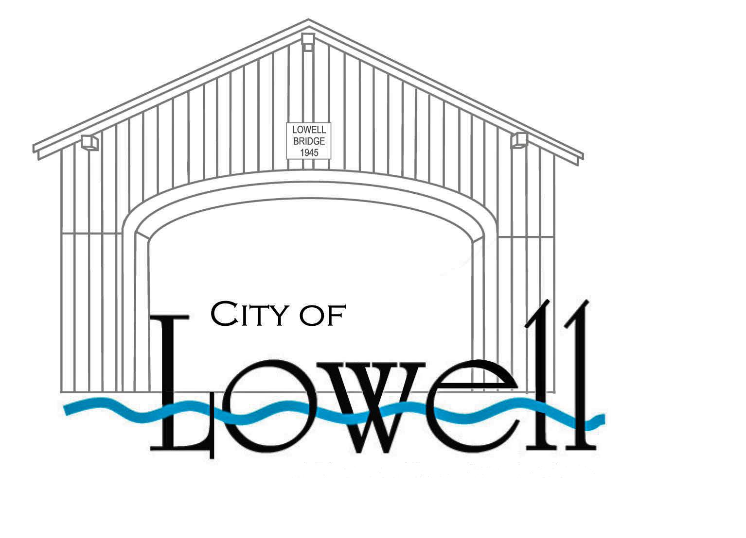

PO Box 490 Lowell, OR 97452
Phone: 541-937-2157 Fax: 541-937-2936
Email: city@lowell-or.gov
_____________________________________________________

NOTICE OF BUDGET COMMITTEE MEETING
Public Hearing

A public meeting of the Budget Committee of the City of Lowell, Lane County, State of Oregon, to discuss the budget for the fiscal year July 1, 2016 to June 30, 2017 will be held in the City Council Chambers at Lowell City Hall, 107 East 3rd Street, Lowell, Oregon 97452.
The meeting will take place on the 4th day of May, 2016 at 6:00 p.m. The purpose of the meeting is to receive the budget message and to receive comments from the public on the budget. A copy of the budget document may be inspected or obtained on or after April 27th, 2016 at City Hall, 107 E. 3rd Street between the hours of 9:00 a.m. and 5:30 p.m. or on the City’s website at www.ci.lowell.or.us on the Budget Page. This is a public meeting where deliberation of the Budget Committee will take place. Any person may appear at the meeting to discuss the proposed programs with the Budget Committee.

